Practical 5 :
Design and evaluate a multi-branch enterprise network using RIP version 2 dynamic routing and centralized DHCP services. Analyze route advertisement, routing-table updates, DHCP relay operation, DHCP DORA packet exchange, packet forwarding, Layer-2 and Layer-3 address changes, traceroute behavior, and alternate-route selection after introducing a failover link using Cisco Packet Tracer.

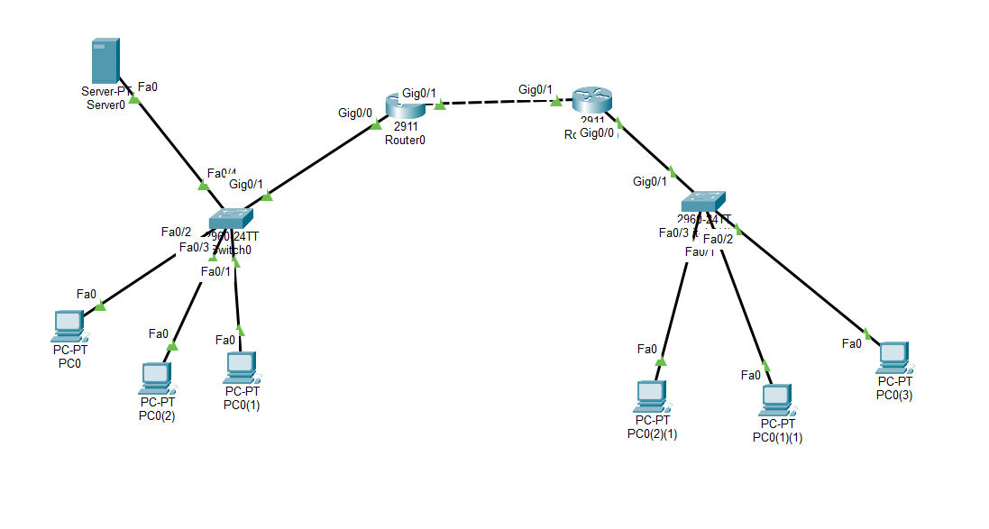
Figure 1 Network Layout for DHCP Services Using Server

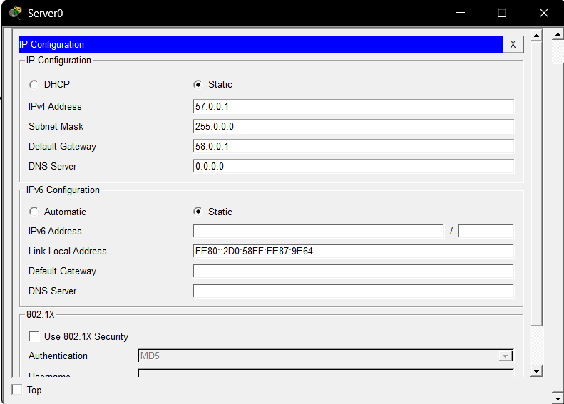

Figure 2 IP Assigning to Server
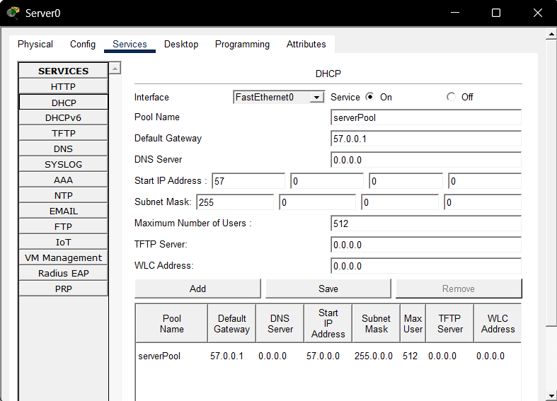

Figure 3 DHCP Service Configuration in Server

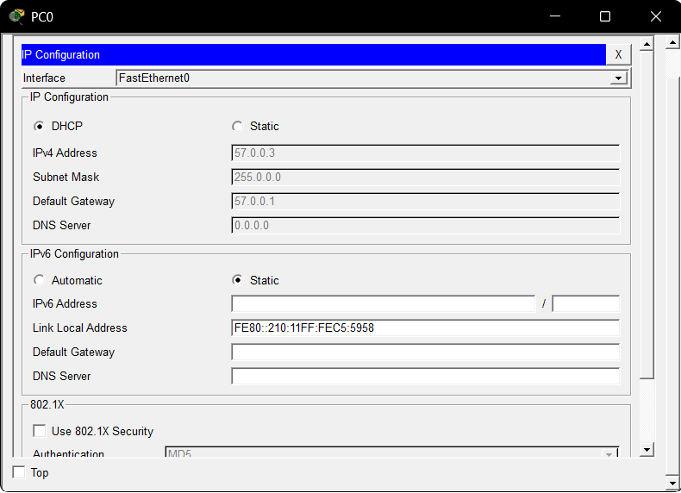

Figure 4 IP Assigning Using DHCP

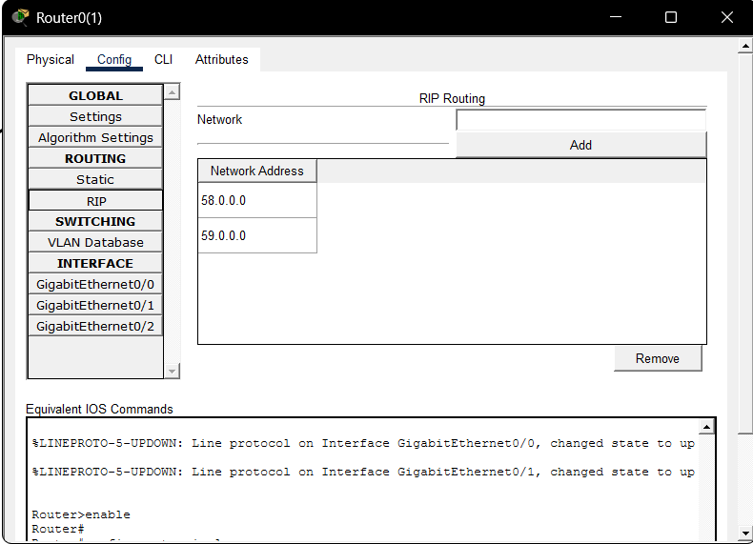
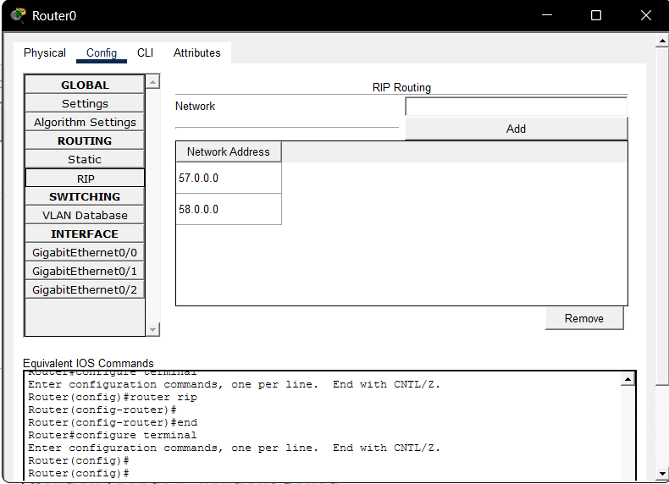

Figure 5 Routing to Network Using RIP

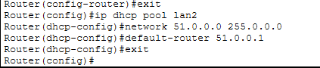

Figure 5 : CLI code in Router

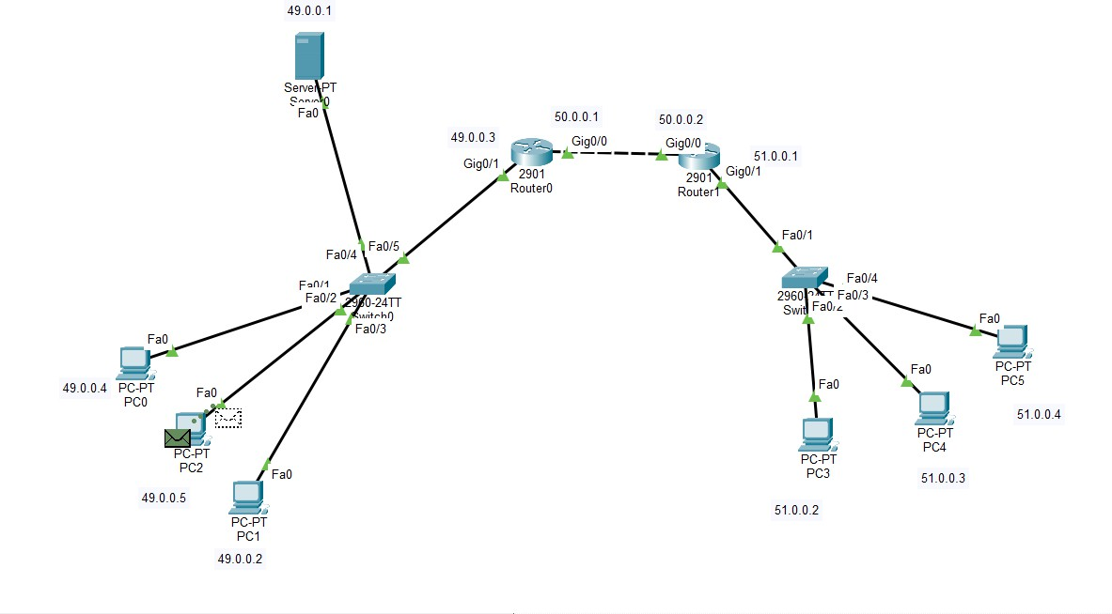

Figure c : Packet Sent from source

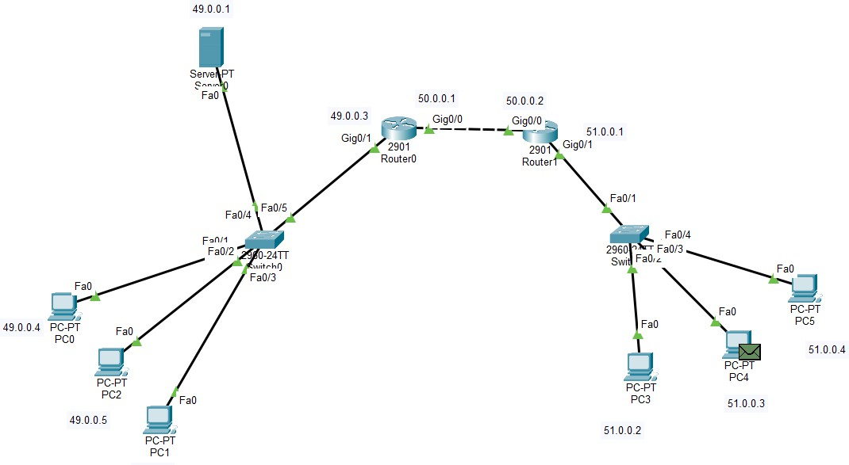

Figure 7 : Packet Arrived at destination

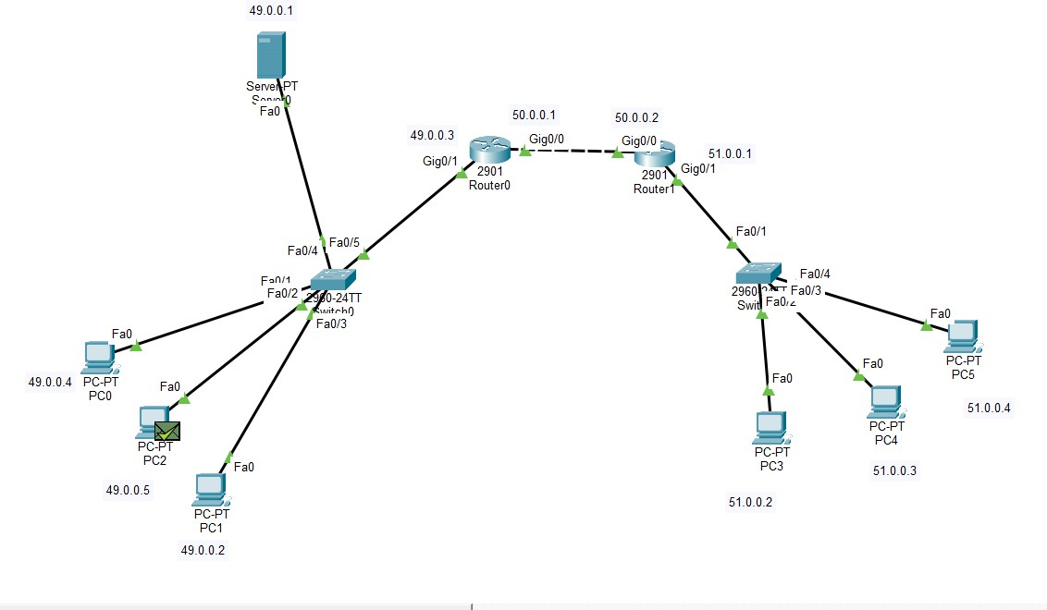

Figure 8 : Acknowledgement Arrived at Source

DHCP Ring Topology

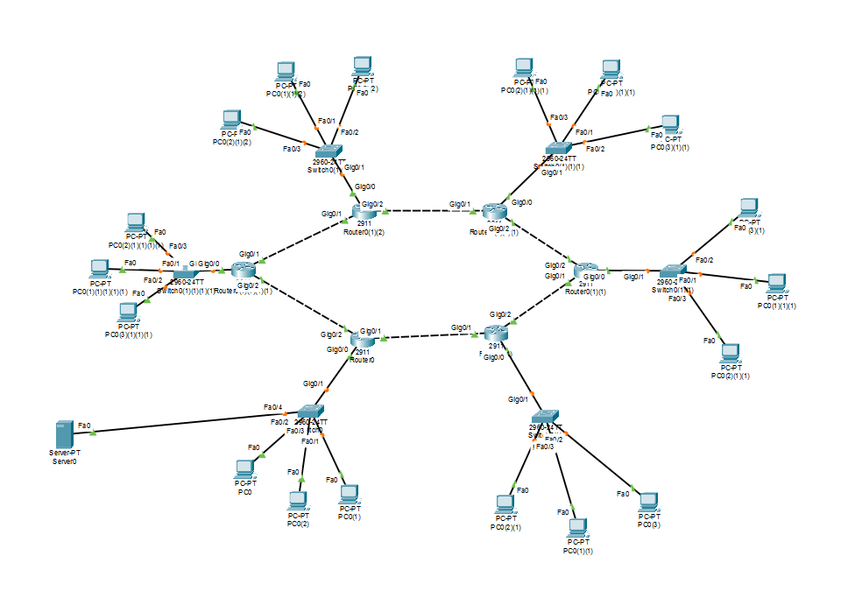
Figure 6 Network Design for Ring Topology

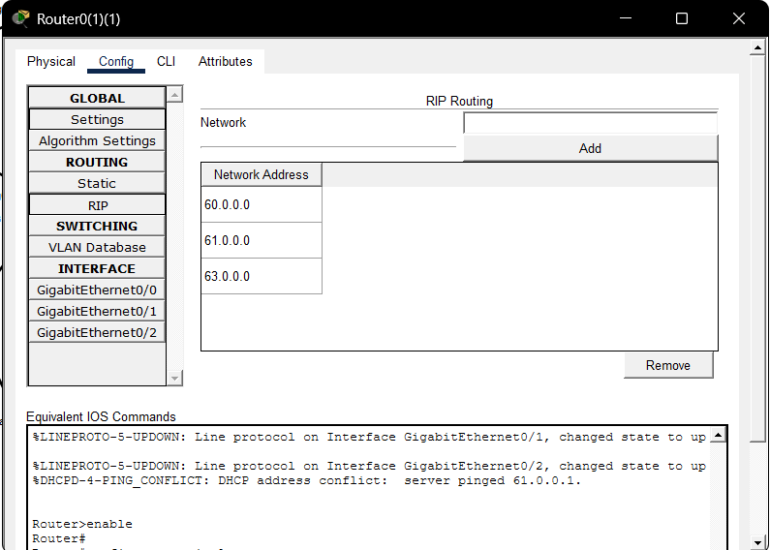

Figure 7 Setting RIP Configuration to connect other Routers

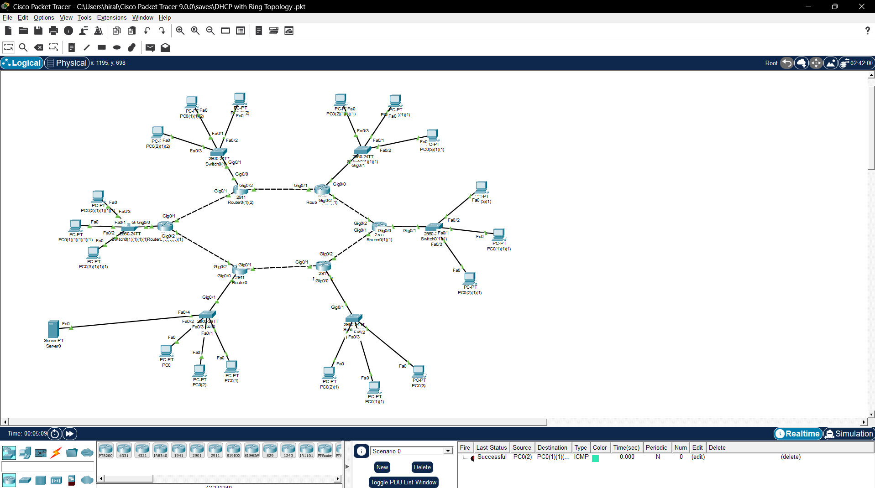

Figure 8 Message Received at PC of Network 4 from Network 1

